

v 1.0.0­

Content

System requirements 3

Database window 4

Settings window 5

Main settings 5

Camera 6

Branding 7

Add interface language 8

Program activation 9

Used libraries 10

In case you have a license, the program’s work is not limited, but a watermark is added to the photos.

# System requirements

Compatibility: Windows 10, 11 x64.

Recommended computer: Intel i5 (8th Gen and above), i7 (4 or more cores), SSD, at least 8GB of RAM.

Required software:

1. .NET 6.0 Desktop Runtime - Windows x64

<https://dotnet.microsoft.com/en-us/download/dotnet/thank-you/runtime-desktop-6.0.13-windows-x64-installer>

1. Microsoft Visual C ++ 2019 redistributable component (both x86 and x64 versions).

<https://aka.ms/vs/17/release/vc_redist.x86.exe>

<https://aka.ms/vs/17/release/vc_redist.x64.exe>

# Database window

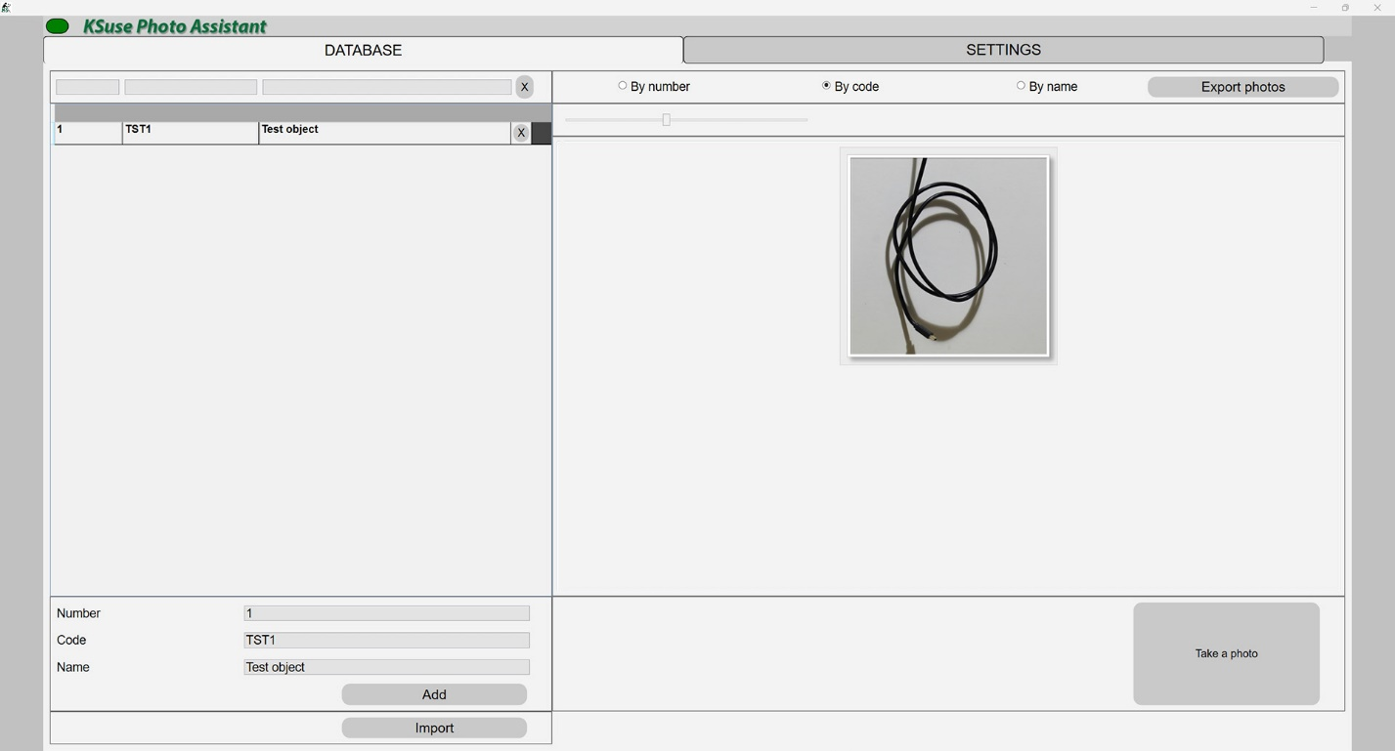

<https://www.youtube.com/watch?v=60Zr3q8_LJg>

# Settings window

## Main settings

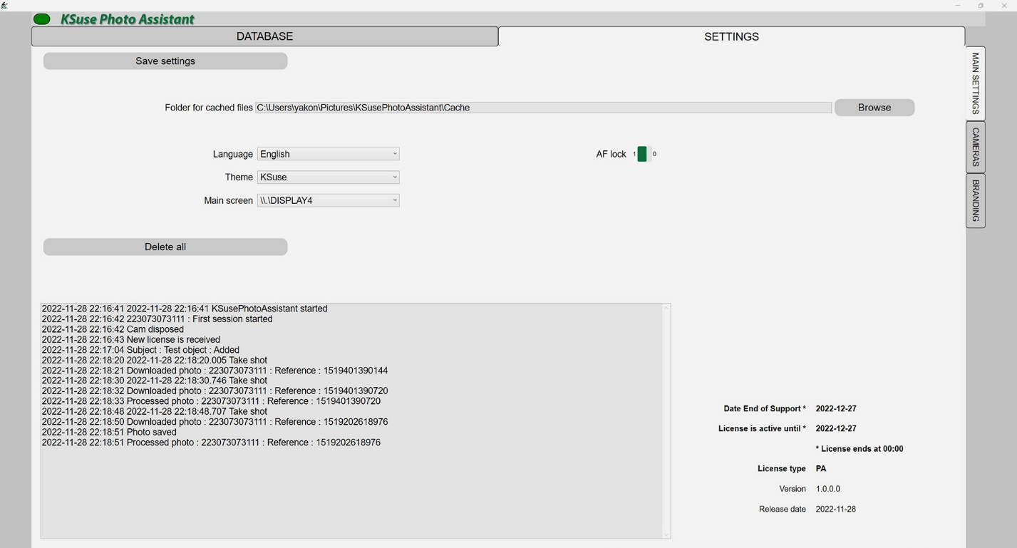

<https://www.youtube.com/watch?v=60Zr3q8_LJg>

## Camera

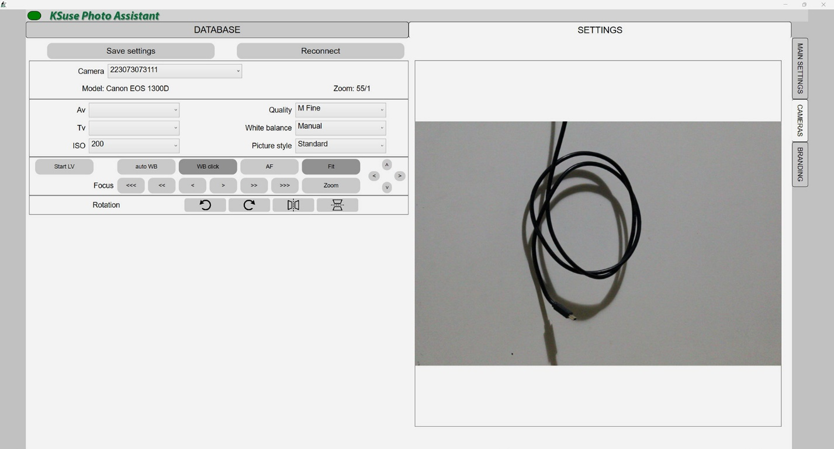

<https://www.youtube.com/watch?v=60Zr3q8_LJg>

## Branding

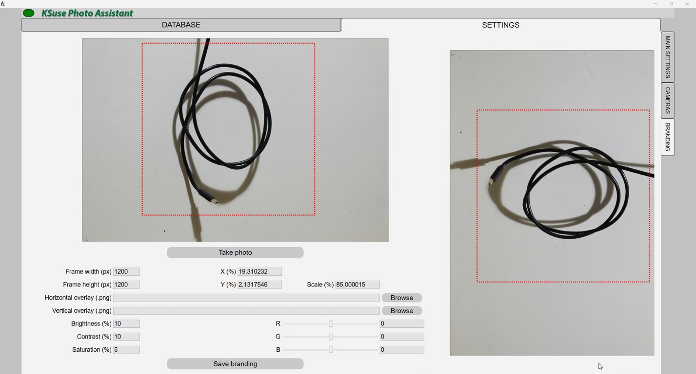

<https://www.youtube.com/watch?v=60Zr3q8_LJg>

# Add interface language

1. Create a copy of C:\Program Files\ksuse.ru\ KSusePhotoAssistant\lang\en.xaml
2. Rename the copy to the two-letter designation corresponding to the new language, for example, ru.xaml
3. Add a new language to the new line in langs.txt in the format designation=name, for example, ru=Russian

# Program activation

Attention! The program is tied to the computer. One license is valid for one computer.

License management is carried out through KSuse Manager.

# Used libraries

Icons made by Freepik from www.flaticon.com is licensed by CC 3.0 BY  
<https://www.flaticon.com/authors/freepik>

Icons made by Smashicons from www.flaticon.com is licensed by CC 3.0 BY  
<https://www.flaticon.com/authors/smashicons>

Icons made by Vitaly Gorbachev from www.flaticon.com is licensed by CC 3.0 BY  
<https://www.flaticon.com/authors/vitaly-gorbachev>

Photo icons created by Pixel perfect – Flaticon  
<https://www.flaticon.com/free-icons/photo>

<http://creativecommons.org/licenses/by/3.0/>

System.Data.SQLite - <https://system.data.sqlite.org>  
Microsoft - <https://dotnet.microsoft.com/>

The MIT License:  
Newtonsoft.Json - <https://www.newtonsoft.com/json>   
Portable.BouncyCastle - <https://www.bouncycastle.org/csharp/>   
SharpZipLib - <https://github.com/icsharpcode/SharpZipLib>   
SQLite-net - <https://github.com/praeclarum/sqlite-net>

Apache License:  
Magick.NET - <https://github.com/dlemstra/Magick.NET>   
NPOI - <https://github.com/tonyqus/npoi>

BSD 3-Clause License:  
NLog - <https://nlog-project.org/>